**Suitability analysis for the use of Sand Washing Waste as Fill in Reinforced Earthen Structures**

**Jaya Ram J R**1**, Soundara B**2

1PG Student, Department of Civil Engineering, College of Engineering Guindy, Anna University,

Chennai-600025, Tamilnadu, India. Email: jrjayaram@yahoo.com

2Assistant Professor, Department of Civil Engineering, College of Engineering Guindy, Anna University, Chennai-600025, Tamilnadu, India. Email: soundra_iit@yahoo.co.in

**Abstract.**

India is the second largest consumer of sand, and the production of manufactured sand (M-sand) has exceeded an annual target of 850 million tons. Its annual demand is expanding at a rate of 15–20%. M-sand production involves different sand-washing techniques which lead to the slurry type waste material (Sand Washing Waste or SWW). The innovative usage of recycled materials is the priority to minimize the depletion of natural resources. The suitability analysis of this SWW as reinforced fill is studied in this research based on the guidelines given in the standards. The different proportions of SWW (0, 20, 40, 50, 60, 80 and 100%) are blended with natural sand. The index properties, compaction characteristics (heavy compaction), permeability (falling head method), and drained shear strength parameters (direct shear test) were studied for all the mix proportions. Based on the test results, it is observed that the non-plastic fine content increases with an increase in SWW, and more than 90% of fines are silt with a coefficient of uniformity greater than 2. The permeability values of different mixes lie in the range of silt. Up to 60% addition of SWW, there is only a marginal increase in OMC for SWW-Sand mixtures, and the drained friction angle observed for those mixtures is greater than 30 degrees. Based on the reinforced fill criteria (IRC SP-102), 60% of SWW can be replaced with natural sand and sustainably used as non-plastic fill material in reinforced (polymeric) earthen structures.

**Keywords:** manufactured sand, sand washing waste, sustainability, reinforced earth fill, recycled material

**1. Introduction**

Manufactured Sand is becoming the norm in the industry and its demand is growing exponentially not just in India but also globally as M-Sand is half the price of river sand. In the state of Tamil Nadu, there are more than 320 stone-crushing plants that produce 68 million tons of waste products (such as dust or sludge) annually. India is the second largest consumer of sand in the World next to China. The global market estimated as of 2025 is 15.2 billion USD. In India, the M-Sand market is about 900 million tons a year and it is growing at 7-8% forecasted for the next five years. The use of Sand Washing Waste (SWW) for geotechnical applications such as earth fills offers tremendous opportunities for resource circulation and pollution prevention.

The present approach to geotechnical engineering promotes the use of a variety of by-products produced worldwide (Manjunath and Soundara, 2021). The scarcity of natural resources has led to the exploitation of different waste materials, including recycled construction and demolition materials debris (Vieira et al. 2022), tire debris (Balunaini and Prezzi, 2010, Balunaini et al. 2014,), sand from foundries (Goodhue et al. 2001), and waste foundry sand and blast furnace steel slag (Lee et al. 2001, Kumar and Parihar 2019). One such alternative material is Sand Washing Waste (SWW), which is generated as a by-product in Manufactured sand (M-sand) production, an alternative to natural river sand. M-sand is gaining popularity in the construction industry due to its consistent quality and availability. However, M-sand production generates a significant amount of waste which is about 15 to 25%, primarily in the form of fine dust particles called Sand Washing Waste. This waste poses environmental concerns and burdens landfills. Finding beneficial applications for SWW is crucial for sustainable resource management. Environmental and economic challenges, making it crucial to investigate their potential utilization in the construction industry as a means to address the issue of waste dumping. SWW exhibits desirable engineering properties, including good compaction characteristics, adequate shear strength, and permeability. Furthermore, its abundant availability makes it a potentially cost-effective and environmentally friendly option for various construction purposes

Kumar and Parihar (2019) conducted experimental investigations on foundry sand and Blast Furnace (BF) slag. They observed that foundry sand has a maximum dry density (MDD) of 16.4 kN/m3 and an optimal moisture content (OMC) of 16%, while BF slag has a MDD of 21 kN/m3 and 10% OMC. They showed the angle of shearing resistance of 310 and 370 for foundry sand and BF slag respectively. Kumar et al. (2019) explored different proportions of granulated rubber and fly ash, ranging from 0% to 60% by weight of fly ash. The shear strength of the composite material is higher than that of fly ash or granulated rubber alone, with the maximum shear strength observed for a granulated rubber content of about 60% by weight of fly ash. The maximum dry unit weight ranges between 15%-22.5% and the optimum water content ranges between 10%-27%. Based on the minimum void ratio, the optimum mix proportions of granulated rubber and fly ash ranged between 54%- 100% and 81%-185% by weight of fly ash.

This experimental study aims to investigate the feasibility of utilizing Sand Washing Waste (SWW) and sand mixtures as backfill materials in reinforced earth. By repurposing this waste material, the study aims to address two significant challenges simultaneously: the reduction of waste generated by the production of M-Sand and the sustainability of construction practices. By evaluating these mixtures’ geotechnical properties and performance, the study seeks to provide valuable insights into their behaviour and assess their potential as viable alternatives to conventional backfill materials.

**MATERIALS USED**

**Sand Washing Waste**

Sand Washing Waste utilized in this study is obtained from waste product generated from the Manufactured sand production from Murugan Factory, Tiruneermalai, Chennai, India. On average, around 1 tonne of manufactured sand is produced. Concurrently, about 250 kg of Sand Washing Waste are gathered from the scrapheaps of M-Sand production plant from the factory premises to perform basic characteristic studies, permeability, and direct shear testing. Consequently, this slurry waste is classified as Sand Washing Waste.

**Sand**

Indian Standard (IS) sand, which is sieved through a 1 mm mesh and retained on a 0.5 mm mesh, is referred to as Ennore sand (IS 650:1991) and is classified as a grade II backfill material. The properties of this sand, including its grain size distribution, specific gravity, and the range of its maximum and minimum densities, are assessed in accordance with the standards IS: 2720-4 (1985), IS: 2720-3 (1963), and IS: 2720-28 (1974).

**2. EXPERIMENTAL WORK**

Before figuring out the engineering properties such as shear strength and permeability, a series of basic characteristic tests were performed on both the materials used. These tests included gradation, specific gravity, heavy compaction, and Atterberg limits for mixture of SWW and Sand. Additionally, X-ray fluorescence testing was conducted to identify the chemical compounds present in the material samples. Scanning Electron Microscope (SEM) studies were also carried out to understand the morphological characteristics of the materials. Drained Direct shear testing was performed at three different normal stresses (50 kPa, 100 kPa, and 150 kPa) to determine the direct shear strength parameters, apparent cohesion (c), and angle of shearing resistance(φ) corresponding peak and residual stress is calculated at 8 mm horizontal displacement. All the characteristics observed for the Sand Washing Waste samples presented below were compared with those of conventional fill material tested by IRC: SP:102- 2014.

**Specific gravity**

The specific gravity values of the samples tested, as per IS: 2720 (Part III/sec 1) 1980, typically range from 2.65 to 2.85. The specific gravity of SWW is 2.69, while that of sand is 2.60. Soil that contains organic matter and has porous particles might have specific gravity values below 2.0. Soil that is rich in heavy materials could have above 3.0. The specific gravity of soil changes depending on its mineral composition, the slurry waste from M-sand production often contains fine particles and sediments that are denser than water, which increases the specific gravity of the Sand Washing Waste.

**Grain size distribution**

Grain size analysis was carried out on Sand, Sand Washing Waste, and the mixture of sand & SWW following the standards set by IS: 2720 (Part IV) - 1985. The Sand Washing Waste from the M-sand slurry contained particles as small as 94% in fines, while the Sand had very little fines, less than 2%. Figure 1 displays a comparison of the particle size distribution of the mixture of Sand and Sand Washing Waste (100%Sand, 80%Sand-20%SWW, 60%Sand-40%SWW, 50%Sand-50%SWW, 40%Sand-60%SWW, 20%Sand-80%SWW, 100%SWW). Table 1 provides details on the gradation characteristics of the Sand & SWW mixture. According to the particle size distribution and the percentage of fines, the Sand and mixture Sand & SWW were categorized as poorly graded sand (SP) and silty sand (SM), respectively. The values for the liquid and plastic limits of the sand and SWW were not determined due to their non-plastic properties.

|  |  |  |  |  |  |  |  |  |
| --- | --- | --- | --- | --- | --- | --- | --- | --- |
| PROPERTY | | 100%Sand | 80%Sand  20%SWW | 60%Sand  40%SWW | 50%Sand  50%SWW | 40%Sand  60%SWW | 20%Sand  80%SWW | 100%SWW |
| Grain Size Analysis (%) | Gravel  Sand  Silt  Clay | 0  98.70  1.26  0 | 0  80.20  16.80  3.00 | 0  61.00  33.00  6.00 | 0  51.00  41.00  8.00 | 0  42.00  49.00  9.00 | 0  24.00  64.00  12.00 | 0  6.00  79.00  15.00 |
| Fines Content (%) | | 1.26 | 18.82 | 39.75 | 49.69 | 57.89 | 76.08 | 94.28 |
| Soil classification | | SP | SM | SM | SM | SM | SM | SM |
| Specific gravity, Gs | | 2.603 | - | - | - | - | - | 2.694 |
| Plasticity index (%) | | Non-Plastic | Non-Plastic | Non-Plastic | Non-Plastic | Non-Plastic | Non-Plastic | Non-Plastic |

*Table 1: Gradation characteristics of mixture Sand & SWW*

*Figure 1. Grain size distribution of mixture Sand & SWW*

**pH Test**

The pH of soil significantly affects its chemical, physical, and biological properties, making it crucial to study this aspect. Soil can be classified as either extremely acidic or extremely alkaline based on its pH level. pH value of 100%SWW is 8.7. The test results indicate that the samples were alkaline, as their pH values exceeded 7.5, M-sand is produced by crushing hard granite or other rock types. If these rocks contain minerals like feldspar or mica, which are silicate minerals, they can contribute to a higher pH when they come into contact with water for Sand Washing Waste.

**Morphology**

C:\Users\HP\AppData\Local\Temp\Rar$DIa0.386\1a.tif**C:\Users\HP\AppData\Local\Temp\Rar$DIa0.014\4a.tif**C:\Users\HP\AppData\Local\Temp\Rar$DIa0.839\3a.tifThe microscopic structure of the particles was examined using Scanning Electron Microscopy (SEM), the samples conductive, they were placed on a surface stud coated with gold. The particles were viewed at various levels of magnification. Figures 2 (a, b & c) depict the samples of Sand Washing Waste viewed at a magnification of 1.10kx, 3.11kx, 5.13kx. It appears that there were more particles in the finer, possibly because it contained a higher proportion of small particles. Through SEM, it was noted that the particles of Sand Washing Waste were irregular, with a few spherical,Fine, Angular Particles: Indicate that the M-sand was likely produced by mechanical crushing. Look for any signs of particle agglomeration, where smaller particles stick together to form larger clusters.

**(b)**

**(c)**

**(a)**

*Figure 2. SEM images of* *Sand Washing Waste at a magnification factor of (a)**1.10kx, (b)**3.11kx, (c)* *5.13kx*

Energy Dispersive X-ray Analysis (EDAX) is an analytical technique used for the elemental analysis or chemical characterization of a sample. Table 2 provides the oxide composition of tested Sand Washing Waste. In SWW, the most abundant components are silica (SiO2) and aluminium oxide (Al2O3). Higher percentage of silica suggests the behaviour of M-sand similar to conventional sand particles.

**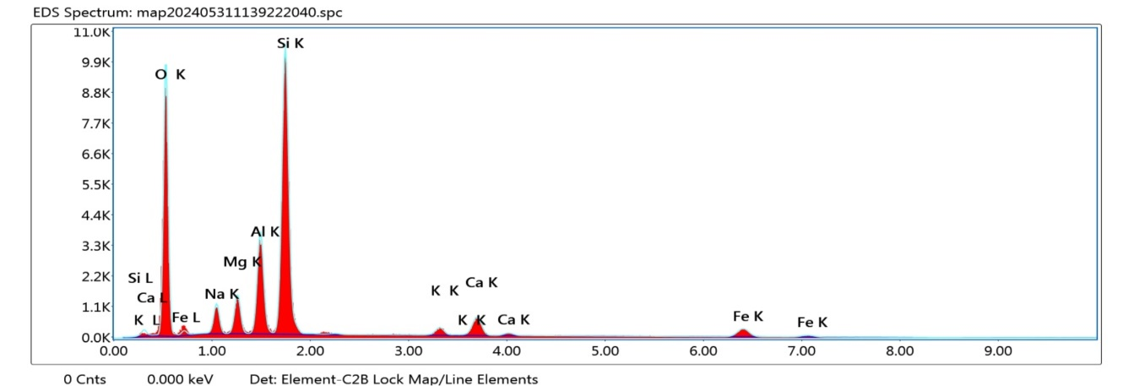***Table 2: Chemical composition of Sand Washing Waste*

|  |  |  |  |  |  |  |  |  |
| --- | --- | --- | --- | --- | --- | --- | --- | --- |
| Chemical composition (%) | SiO2 | Al2O3 | Fe2O3 | CaO | K2O | TiO2 | SO3 | MnO |
| 59.78 | 17.81 | 10.69 | 7.38 | 2.46 | 1.03 | 0.25 | 0.126 |

*Figure 3: EDAX spectra Micromorphology of Sand Washing Waste*

Figure 3 shows the micromorphology of SWW elements with their weight percentage and net counts are listed in Table 3. Carbon(C), Oxygen(O), Sodium(Na), Magnesium(Mg), Aluminium(Al), Silicon(Si), Potassium(K), Calcium(Ca), Titanium(Ti) and Iron(Fe) minerals are identified in the samples. Oxygen (O), Aluminium (Al), and Silicon (Si) are the three minerals that are highly present in the samples.

*Table 3: Net Counts and Weight% of minerals*

|  |  |  |  |  |
| --- | --- | --- | --- | --- |
| Element | Weight % | Atomic % | Net Int. | Error % |
| O K | 37.45 | 52.73 | 358.89 | 7.89 |
| NaK | 4.25 | 4.17 | 45.47 | 7.95 |
| MgK | 4.02 | 3.72 | 64.10 | 6.29 |
| AlK | 10.31 | 8.61 | 176.87 | 4.78 |
| SiK | 29.79 | 23.90 | 529.57 | 4.10 |
| K K | 1.77 | 1.02 | 18.00 | 11.14 |
| CaK | 5.38 | 3.02 | 46.01 | 4.76 |
| FeK | 7.03 | 2.84 | 25.71 | 5.82 |

**Compaction characteristics**

Modified Proctor compaction tests were conducted on all proportions of Sand and SWW mixtures. The compaction curves for all mixtures were plotted and presented in Figure 4. The maximum dry density (MDD) and optimum moisture content (OMC) for all samples were obtained from the compaction curve are given in Table 4, The maximum dry density of samples ranges from 21.39 kN/m3 to 18.62 kN/m3,while the optimum moisture content values range from 6.83 % to 11.33 %.

*Table 4: Modified Proctor Compaction results of Sand and SWW mixture*

|  |  |  |  |  |  |  |  |
| --- | --- | --- | --- | --- | --- | --- | --- |
| PROPERTY | 100 % Sand | 80%Sand  20%SWW | 60%Sand  40%SWW | 50%Sand  50%SWW | 40%Sand  60%SWW | 20%Sand  80%SWW | 100 % SWW |
| MDD γdmax (kN/m3) | 18.63 | 21.39 | 21.24 | 21.16 | 20.10 | 19.55 | 18.62 |
| OMC (%) | - | 6.83 | 6.92 | 6.99 | 10.56 | 10.70 | 11.33 |

In the present study, the MDD of the sample for standard proctor compaction energy varied from 17.26 kN/m3 to 20.89 kN/m3, and OMC varied from 14.34 % to 10.08 %. In the case of the modified proctor compaction, MDD varied from 18.62 kN/m3 to 21.39 kN/m3, and OMC varied from 11.33 % to 6.83 %. It is generally accepted that modified compaction will give a higher MDD and a lower OMC than standard compaction for the same material. The modified OMC is generally about 2% lower than in standard compaction but this rule of thumb is not consistent for all materials.

*Figure 4: Modified Proctor Compaction curves of Sand and SWW mixture*

Devaraj et al. (2023) has reported a MDD of 14.91 kN/m3 for M-sand slurry waste and an OMC of 17.6 % which is similar to the result conducted by the laboratory test of 100% SWW. Kumar et al (2019) showed a decrement in OMC with the addition of different percentages of granulated rubber in the mixture ranging from 20% to 15%. The decrease in OMC is due to the addition of coarse-grained particles (in the form of granulated rubber). In this present investigation, the OMC showed an increment with the addition of different percentages of SWW in the mixture due to an increase in fine-grained soil proportion.

**Permeability Characteristics**

The rate of flow of water, under laminar flow conditions, through a unit cross-sectional area of soil mass, under a unit hydraulic gradient, is defined as the coefficient of permeability. Soil samples passed through 4.75 mm were compacted at their maximum dry density and optimum moisture content in permeability mould. The prepared samples in mould were allowed for saturation. Then the Falling head permeability tests were carried out for all mixtures of Sand and SWW samples in accordance with IS: 2720 (Part XVII) 1986: codal procedure.

The coefficient of permeability values for all samples were obtained through the permeability test and reported in Table 5. The results suggested that the coefficient of permeability ranged from 8.886 x 10-3 cm/sec to 9.079 x 10-5 cm/sec upon increasing the SWW%. The range of permeability for silty sand is 10-3 to 10-5 cm/sec. further, the coefficient of permeability for fine sands, silts, and mixtures comprising sand, silts, and clay usually ranges from 10-3 to 10-7 cm/sec. The permeability of the soil samples analyzed in this study appears to fall within this range.

|  |  |  |  |  |  |  |  |
| --- | --- | --- | --- | --- | --- | --- | --- |
| PROPERTY | 100%Sand | 80%Sand  20%SWW | 60%Sand  40%SWW | 50%Sand  50%SWW | 40%Sand  60%SWW | 20%Sand  80%SWW | 100%SWW |
| Permeability (cm/sec) | 8.886 x 10-3 | 6.4103 x 10-3 | 5.106 x 10-4 | 3.650 x 10-4 | 2.384 x 10-4 | 1.1561 x 10-4 | 9.079 x 10-5 |

*Table 5:* *Coefficient of permeability for mixture of Sand and SWW*

To comprehend the binding properties of two materials (Sand and Sand Washing Waste) utilized in the study, MDD were calculated for the compacted mixtures in the Modified Proctor compaction. SWW contents were varied as 0%, 20%, 40%, 50%, 60%, and 100% (by weight of natural Sand). Figure 4, shows the variation of Maximum Dry Density of the compacted mixture with SWW content. The shape of the compaction curve typically rises to a peak (MDD) and then declines as moisture content increases, illustrating that there is an optimal level of water that helps in compaction. According to IRC-SP-102-2014, the maximum dry density (MDD) for Modified Proctor Compaction should fall within the range of 20 kN/m3 to 25 kN/m3. There was no significant segregation of SWW in the mixture, even with a high SWW content. Primarily due to the presence of water in the mixture. 40%–60% addition of SWW (by weight of Sand). However, 0%SWW & 20%SWW replacement is not considered for future testing since the replacement percentage is negligible and not economical.

Hence, further Drained Direct Shear tests have been carried out for the following 3 mix proportions: 60% Sand-40%SWW, 50%Sand-50%SWW, 40%Sand-60%SWW.

**Drained direct shear**

The shear box with sample and perforated grid plates and porous stones fitted into the shear box and samples with dimensions of 60mm x 60mm, were soaked prior to testing as shown in Figure 5. After the application of normal stress such as 50 kN/m2, 100 kN/m2, and 150 kN/m2 and tests were conducted as per IS: 2720 (Part XIII) 1983, the sample was allowed to consolidate. When the consolidation has completely occurred, the shear test was done at such a slow rate that at least 95 percent pore pressure dissipation occurs using the calculated time factor from the consolidation test.

The consolidated drained direct shear tests were carried out for three different soil mixtures: 60%Sand-40%SWW, 50%Sand-50%SWW and 40%Sand-60%SWW. The coefficient of consolidation CV are 0.0228–0.0408 cm2/sec, 0.0221-0.0396 cm2/sec and 0.0218–0.0393 cm2/sec, which is used to estimate the strain rate and time required for failure of the soil samples, was obtained from an oedometer consolidation test. The strain is maintained at a rate of 0.125 mm/min.

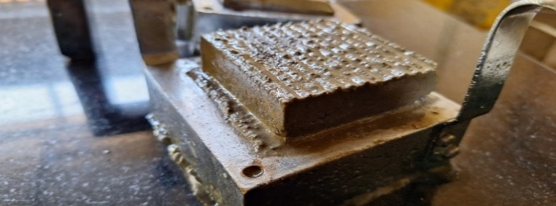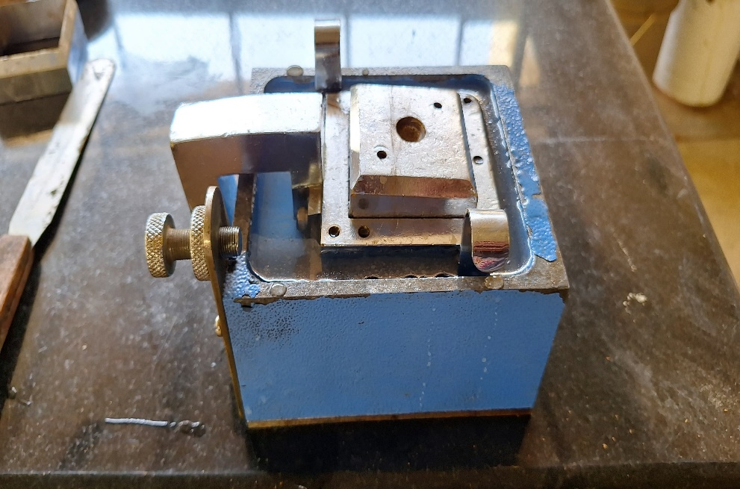

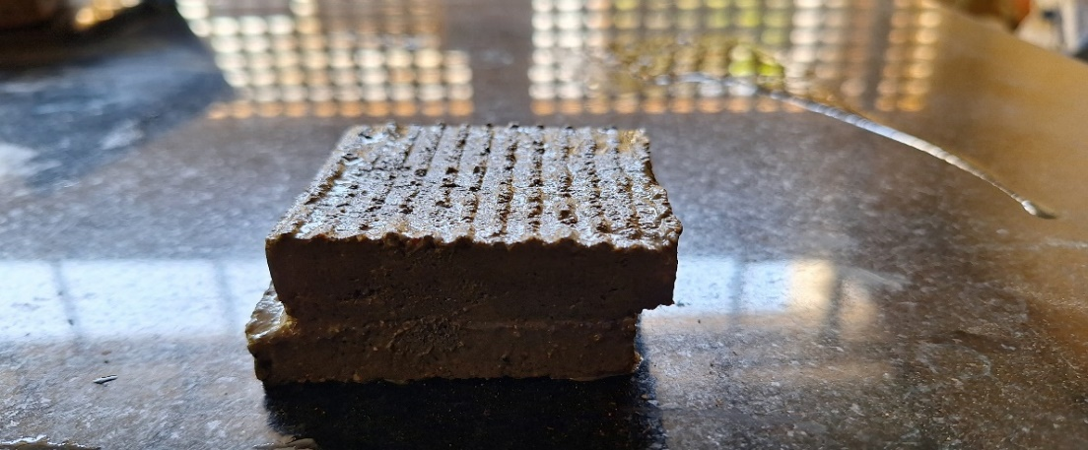

*Figure 5: Sample soaked prior to testing and after failure*

The peak value of ɸdesign, which represents the maximum value of ɸ, should be considered. This peak value can be determined by performing a test as outlined in IS 2720 part IV for drained direct shear. The residual value of shear is considered for 8 mm horizontal displacement. The angle of internal friction decreases with the addition of SWW to the Sand in which the peak value of friction angle for three mixtures of Sand and SWW are 38.83o, 38.48o & 38.30o and the corresponding residual angle of friction is 37.37o, 37.30o & 37.05o.

*Table 6:**Peak & Residual stress corresponding to normal stress reported*

|  |  |  |  |  |  |
| --- | --- | --- | --- | --- | --- |
| **Samples** | **Normal Stresses**  **( kN/m2 )** | **Peak Stress**  **( kN/m2 )** | **Residual Stress**  **( kN/m2 )** | **Maximum Dry Density**  **(kN/m3)** | **Optimum Moisture Content (%)** |
| 60%Sand - 40%SWW | 50 | 47.4 | 30.6 | 21.238 | 6.920 |
| 100 | 97.9 | 80.8 |
| 150 | 127.9 | 107.0 |
| 50%Sand - 50%SWW | 50 | 52.5 | 41.8 | 21.160 | 6.992 |
| 100 | 101.4 | 80.5 |
| 150 | 132.0 | 118.0 |
| 40%Sand -60%SWW | 50 | 42.3 | 27.5 | 20.100 | 10.558 |
| 100 | 81.0 | 72.4 |
| 150 | 121.3 | 103.0 |

The soaked failure envelopes of mixture of SWW & Sand gave friction angles slightly greater than as-compacted sands, with almost no adhesion. A representative soaked failure envelope of these samples is presented in Figure 6-8 for 60%Sand-40%SWW, 50%Sand-50%SWW, 40%Sand-60%SWW. The soaked failure envelope is parallel to the as-compacted envelope, with an adhesion intercept near zero. The soaked sample is allowed to strain at the rate of 0.125 mm/min in which peak and residual stress are calculated and the results are given in Table 6.

*Figure 6:**Soaked failure envelope of 60%Sand-40%SWW*

*Figure 7:**Soaked failure envelope of 50%Sand-50%SWW*

*Figure 8:**Soaked failure envelope of 40%Sand-60%SWW*

The study examined the relationship between shear stress and horizontal displacement for samples made from Sand and Sand Washing Waste. The results were found to exhibit a behavior that was comparable to that observed in mixtures prepared from Foundry Sand Goodhue et al. (2001). However, due to space limitations, the variations observed in the other mixtures considered for the study were not presented. From Figures 6-8, it was noted that the initial slope of the relationship between shear stress and horizontal displacement decreased as the percentage of Sand Washing Waste (SWW) in the mixture increased. This suggests a decrease in the shear modulus of the mixtures with the addition of SWW. The shear stress was observed to escalate in a linear manner with the horizontal displacement of the lower box, with the peak behavior occurring at the allowable horizontal displacement of the lower box, which was measured to be 8 mm. This behavior is indicative of the material's contractive properties.

The analysis involves a comparison between the peak shear strength envelope of the optimal Sand and Sand Washing Waste (50% SWW by weight of sand) as determined in this study. The shear strength parameters of the sand and sand washing waste mixtures determined in this study were found to exceed those of the tire shreds and sand mixtures reported by Kumar et al. (2019). It was observed that the shear strength of mixtures primarily depends on the size and shape of the sand-washing waste particles, the percentage of sand-washing waste in the mixture, the compaction effort, the type of soil, and the particle size distribution. The addition of water was made to prevent the segregation of sand washing waste particles in the mixtures tested. The elevated shear strength values indicate that the mixtures of sand and sand-washing waste could serve as competent fill material.

**3. Conclusions**

An experimental program was devised and carried out to assess the suitability of Sand Washing Waste (SWW) as a fill material in reinforced earthen structures. The basic characterization of SWW was done based on the index properties such as specific gravity, grain size distribution (sieve and hydrometer analyses), and Atterberg limits. The compaction characteristics of different mix proportions of SWW with sand are arrived at by light and heavy compaction tests. The permeability of the mixes is determined using falling head permeability tests. The coefficient of consolidation and drained shear strength of the different mix proportions of SWW are evaluated using conventional one-dimensional consolidation tests and direct shear tests. The important findings from the laboratory investigation are discussed in the following section

1. As per the Indian Standard (IS) classification system, SWW samples are classified as silty sand (SM).
2. The maximum dry density of samples ranges from 20.89 kN/m3 to 17.26 kN/m3,while the optimum moisture content values ranged from 10.08 % to 14.34 % upon increasing the SWW from 20% to 100% under standard compaction. This trend is due to the increase in fine content upon increasing the SWW %.
3. Upon heavy compaction, the maximum dry density of samples ranges from 21.39 kN/m3 to 18.62 kN/m3,while the optimum moisture content values range from 6.83 % to 11.33 %. It is generally accepted that modified compaction will give a higher MDD and a lower OMC than standard compaction for the same material.
4. The coefficient of permeability for all mixtures of Sand– SWW ranged from 8.886 x 10-3 cm/sec to 9.079 x 10-5 cm/sec. The range of permeability for silty sand is 10-3 to 10-5 cm/sec. Further, the coefficient of permeability for fine sands, silts, and mixtures comprising sand, silts, and clay usually ranges from 10-3 to 10-7 cm/sec. The permeability of the soil samples analyzed in this study appears to fall within this range.
5. The soaked failure envelopes of the mixture of SWW-Sand gave friction angles slightly greater than the as-compacted dry and wet mix, soaking the samples and testing them under fully drained conditions caused a decrease in interface adhesion. The peak values for three mixes 60%Sand-40%SWW, 50%Sand-50%SWW, and 40%Sand-60% SWW are 38.83o, 38.48o, and 38.30o respectively.
6. The compressibility characteristic of SWW falls in the range of the same for silty sand.
7. The pH value of SWW is 8.7 classified as more alkaline characteristic.
8. The micromorphology of SWW elements with their weight percentage and net counts, Oxygen(O), Aluminium(Al), and Silicon(Si) these three minerals are highly present in the samples.

From the comprehensive experimental investigations, it can be concluded that an optimum mix proportion of 60%SWW with 40%Sand can serve as a fill material for reinforced earth structures meeting the requirements mentioned in IRC: SP:102-2014.

**References**

1. Kumar A. and Parihar A. (2023). Experimental study on waste foundry sand as partial replacement of retaining wall backfill. *Constr. Build. Mater*. 402, 132947, doi: 10.1016/j.conbuildmat.2023.132947.
2. Kumar, B., Prabhakara, K. Guda, P. V Balunaini, U. (2019). Optimum Mixing Ratio and Shear Strength of Granulated Rubber – Fly Ash Mixtures Materials. *J. of Materials in Civil Engineering,* 31(4), doi: 10.1061/(ASCE)MT.1943-5533.0002639.
3. Vieira C. S., and Pereira, P. M. (2022). Influence of the Geosynthetic Type and Compaction Conditions on the Pullout Behaviour of Geosynthetics Embedded in Recycled Construction and Demolition Materials. *Sustainability*, https:// doi.org/10.3390/su14031207.
4. Goodhue, M.J., Edil, T.B., and Benson, C.H. (2001). Interaction of foundry sands with Geosynthetics. *J. of Geotechnical and Geoenvironmental Engineering*, 127 (4), 353- 362.
5. Manjunath, N.V and Soundara, B (2021). A review on the application of industrial waste as reinforced earth fills in mechanically stabilized earth retaining walls. *Environ. Sci. Pollution, Res.*, no. 0123456789, doi: 10.1007/s11356-021-17953-x.
6. Balunaini, U., Yoon, S., Prezzi M. and Salgado, R. (2014). Pullout Response of Uniaxial Geogrid in Tire Shred – Sand Mixtures. *Geotech Geol Eng,* 32, 505–523, doi: 10.1007/s10706-014-9731-1.
7. Lee, Jaeyoon Cho, R. Salgado, and Inmo Lee. (2001). Retaining Wall Model Test with Waste Foundry Sand Mixture Backfill Retaining Wall Model Test with Waste Foundry Sand Mixture Backfill. *Geotechnical Testing Journal*, 24(4), doi: 10.1520/GTJ11137J.
8. Balunaini, U., Prezzi, M. (2010). Interaction of Ribbed-Metal-Strip Reinforcement with Tire Shred–Sand Mixtures. *Geotech Geol Eng,* 28, 147–163. https://doi.org/10.1007/s10706-009-9288-6
9. Devaraj, V., Mangottiri, and Soundara, B. (2023). Prospects of sustainable geotechnical applications of manufactured sand slurry as controlled low-strength material. *Constr. Build. Mater.* 400, 132747, doi: 10.1016/j.conbuildmat.2023.132747.
10. Kumar, V., Mohan, D., Kim, H., Balunaini, U.and Prezzi, M. (2016). Pullout capacity of ladder-type metal reinforcements in tire shred-sand mixtures. *Constr. Build. Mater.* 113, 544–552, doi: 10.1016/j.conbuildmat.2016.02.160.